Your Paper's Title Starts Here (Arial, 16 points)
Thomas Edison^{1, a}, First-name Family-name^{1,b} , First-name Family-name^{2,c} and Others(Arial, 14 points)^{3,d}
¹Faculty of Technology, World University, 1-5-1 Academic village, Innovation City 777-7777, Japan (Arial, 11 points)
²Faculty/School/Division, Institution, Postal address of the co-author including country
³List the addresses of all the authors in the same way
ª<e-mail address>, ^{b}<e-mail address>, ^{c}<e-mail address>, ^{d}<e-mail address>
Keywords: journal, format, instructions to authors, reproducing kernels, support vector machine (Arial, 11 points. Max 5 words, all small letters)
For the rest of the paper, please use Times Roman (Times New Roman, 12 points) in text.

Abstract. This document explains and demonstrates how to prepare your camera-ready manuscript for proceedings of ICTSS2019. Please copy your text without format to this template. The abstract should consist of one paragraph of about 150 words. The abstract should present a concise statement of the scope, principal findings, and conclusions of the paper. Abstracts cannot include lists, tables, figures, display equations, footnotes, or references.

1. Introduction
With an aim to ensure that all contributions published in this journal have a uniform appearance, authors are kindly asked to generate a PDF document that meets the formatting specifications outlined in this document. The paper should be prepared in Microsoft Word. General specifications, including margins, fonts, citation styles, and figure placement are outlined in following sections.
This document provides a template and guidelines for authors using MS-Word ONLY to prepare a paper for this journal. Please follow the instructions carefully.
2. Organization of the Text
2.1 Section Headings, Page Numbers and Tables
The section headings are in boldface capital and lowercase letters. Second level headings are typed as part of the succeeding paragraph (like the subsection heading of this paragraph).
Page Numbers. Do not print page numbers.
Tables. Tables (refer with: Table 1, Table 2, ...) should be presented as part of the text, but in such a way as to avoid confusion with the text. A descriptive title should be placed above each table. Units in tables should be given in square brackets [meV].
2.2 Special Signs, Figures and Equations
Special Signs. for example , α γ μ Ω () ≥ ± ● Γ {110} should always be written in with the fonts Times New Roman or Arial.
Figures. Figures (refer with: Fig. 1, Fig. 2, ...) also should be presented as part of the text, leaving enough space so that the caption will not be confused with the text. The caption should be self-contained and placed below or beside the figure. Generally, only original drawings or photographic reproductions are acceptable. Letters in figures should be Arial. Only very good photocopies are acceptable. Utmost care must be taken to insert the figures in correct alignment with the text. Half-tone pictures should be in the form of glossy prints. If possible, please include your figures as graphic images in the electronic version. For best quality the pictures should have a resolution of 300 dpi (dots per inch).

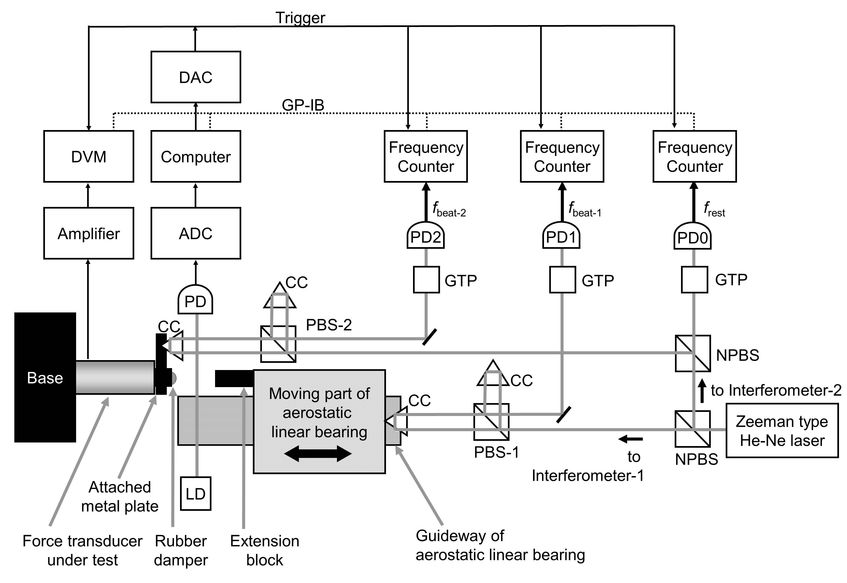
Fig. 1. Experimental Setup (Arial, 12 points). Code: CC= cube corner prism, PBS= polarizing beam splitter, NPBS= non- polarizing beam splitter, GTP= Glan-Thompson prism, PD= photo diode．Captions of figures and tables are Arial (Arial New Roman, 12 points)

Equations. Formulas (refer with: Eq. (1), Eq. (2), …except at the beginning of a sentence: “Equation (1) is ...”) are centered and numbered consecutively. The numbers should be enclosed in parentheses and aligned right. An extra line should be placed above and below of the displayed expression.

$c^{2}=a^{2}+b^{2}$ (1)
2.3 Literature References
References are cited in the text just by square brackets [1]. (If square brackets are not available, slashes may be used instead, e.g. /2/.) Two or more references at a time may be put in one set of brackets [3,4]. The references are to be numbered in the order in which they are cited in the text and are to be listed at the end of the contribution under a heading References, see our example below.
3. Conclusion
Although a conclusion may review the main points of the paper, do not replicate the abstract in the conclusion. A conclusion might elaborate on the importance of the work or suggest applications and extensions.
Acknowledgements
Acknowledgements and Reference heading should be left justified, bold, with the first letter capitalized but have no numbers. Text below continues as normal.

Appendix A
Authors including an appendix section should do so before References section. Multiple appendices should all have headings in the style used above. They will automatically be ordered A, B, C etc.

Appendix B

References
[1] R(=first letter of first name). Araki(=family name), A. Takita, T. Ishima, H. Kawashima, N. Pornsuwancharoen, S. Punthawanunt, E. Carcasona and Y.Fujii, " Impact force measurement of a spherical body dropping onto a water surface(=title of paper)", Rev. Sci. Instrum. (=Italic & bold) , Vol. 85, No. 7, 075116, 2014. (“075116” is paper ID. No page number is available for this journal.)
[2] N. Miyashita, K. Watanabe, K. Irisa, H. Iwashita, R. Araki, A. Takita, T. Yamaguchi and Y. Fujii, " Software for correcting the dynamic error of force transducers", Sensors, Vol.14, No.7, pp.12093-12103, 2014.
[3] K. Maru, K. Kobayashi and Y. Fujii, Multi-point differential laser Doppler velocimeter using arrayed waveguide gratings with small wavelength sensitivity, Optics Express, Vol. 18, No. 1, pp. 301-308, 2010.
[4] Y. Fujii and D.W. Shu, “Optical method for evaluating the impact response of 1” HDD arm”, Proc. AOMATT 2007 (Chengdu, China) July 2007.
[5] K. Maru and Y. Fujii, "Laser Doppler velocimetry technology for integration and directional discrimination" in Optical Imaging Devices: New Technologies and Applications, CRC Press, FL/USA, 2016, pp. 189-206.
[6] Y. Fujii, N. Yoshiura, N. Ohta and A. Takita, Japanese Patent Application No.2015-167298.
[7] Y. Fujii and N. Yoshiura, Japanese Patent No.5757048.
[8] Society for e-JIKEI network: http://www.e-jikei.org/index_e.htm

